
Stewartry
March Quiz
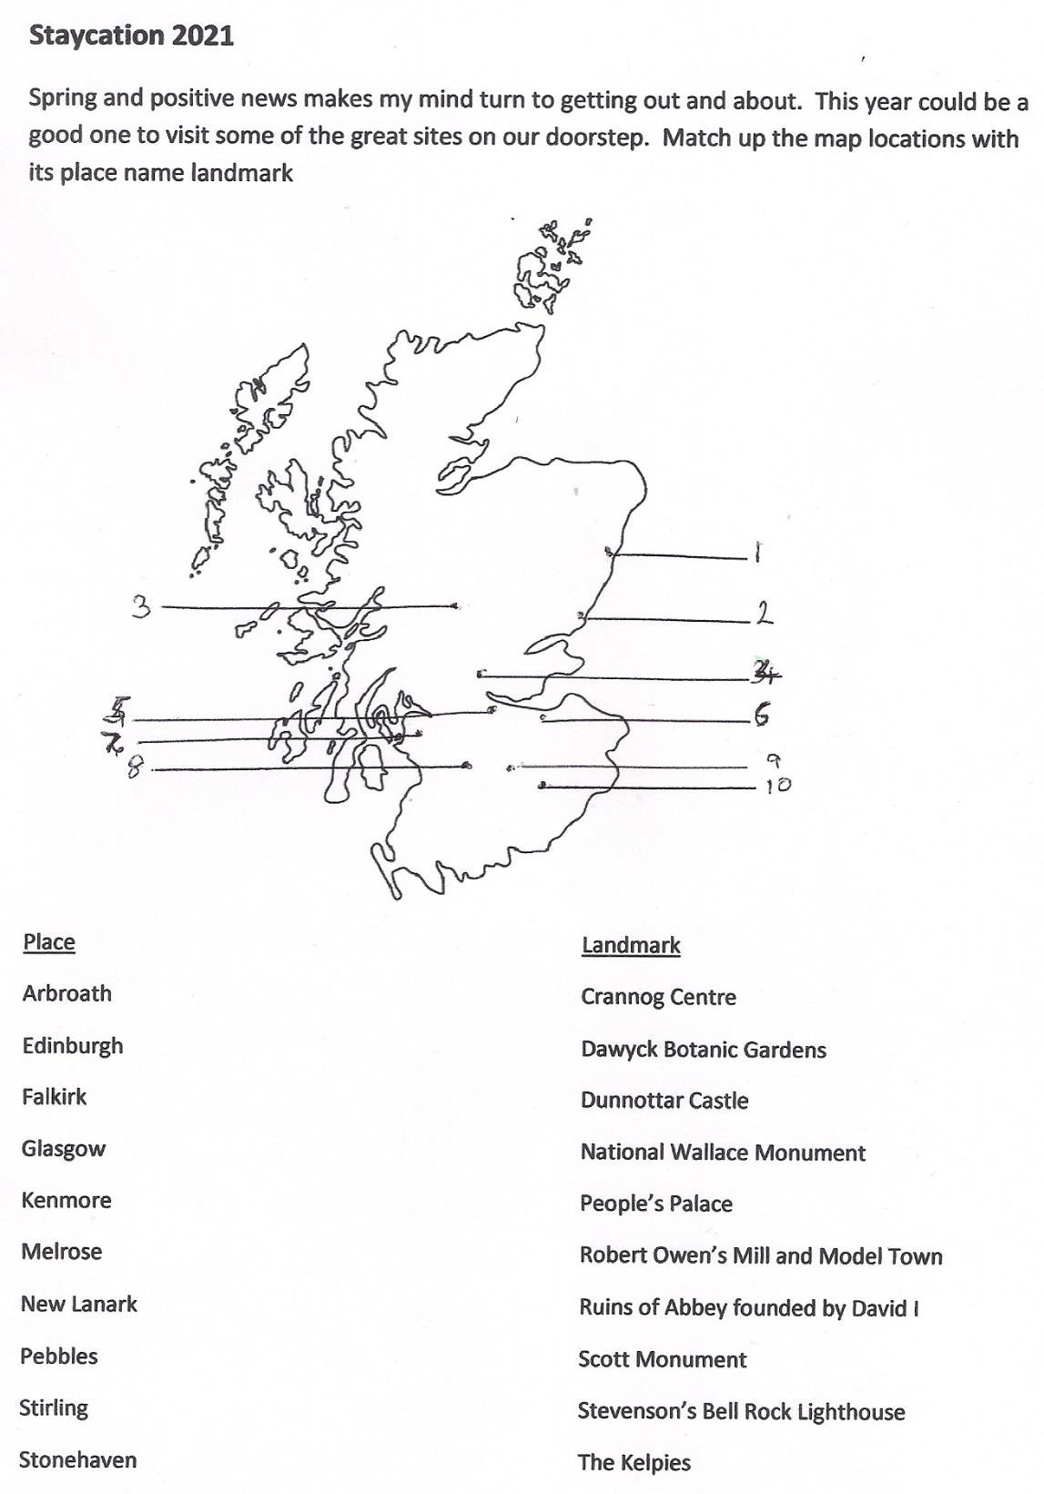
March Quiz Answers

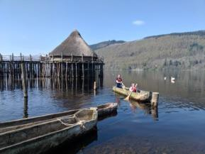  1. Kenmore: Crannog Centre | 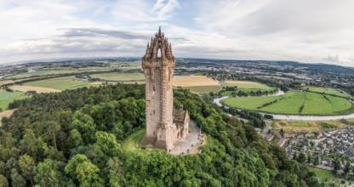  4. Stirling: National Wallace Monument
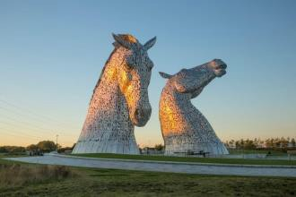  2. Falkirk: The Kelpies | 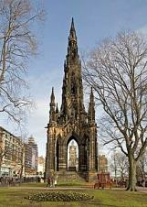  6. Edinburgh: Scott Monument
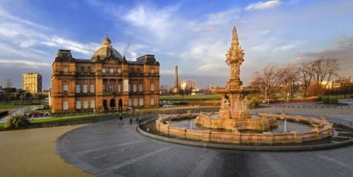  7. Glasgow: People’s Palace | 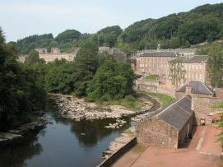  8. New Lanark: Robert Owen’s Mill  /Model Town
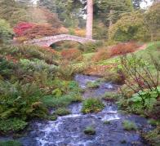  9. Pebbles: Dawyck Botanic Gardens | 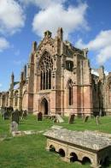  10. Melrose: Abbey Ruins

