
Stewartry

February Quiz – Local Delicacies (answers on next page)
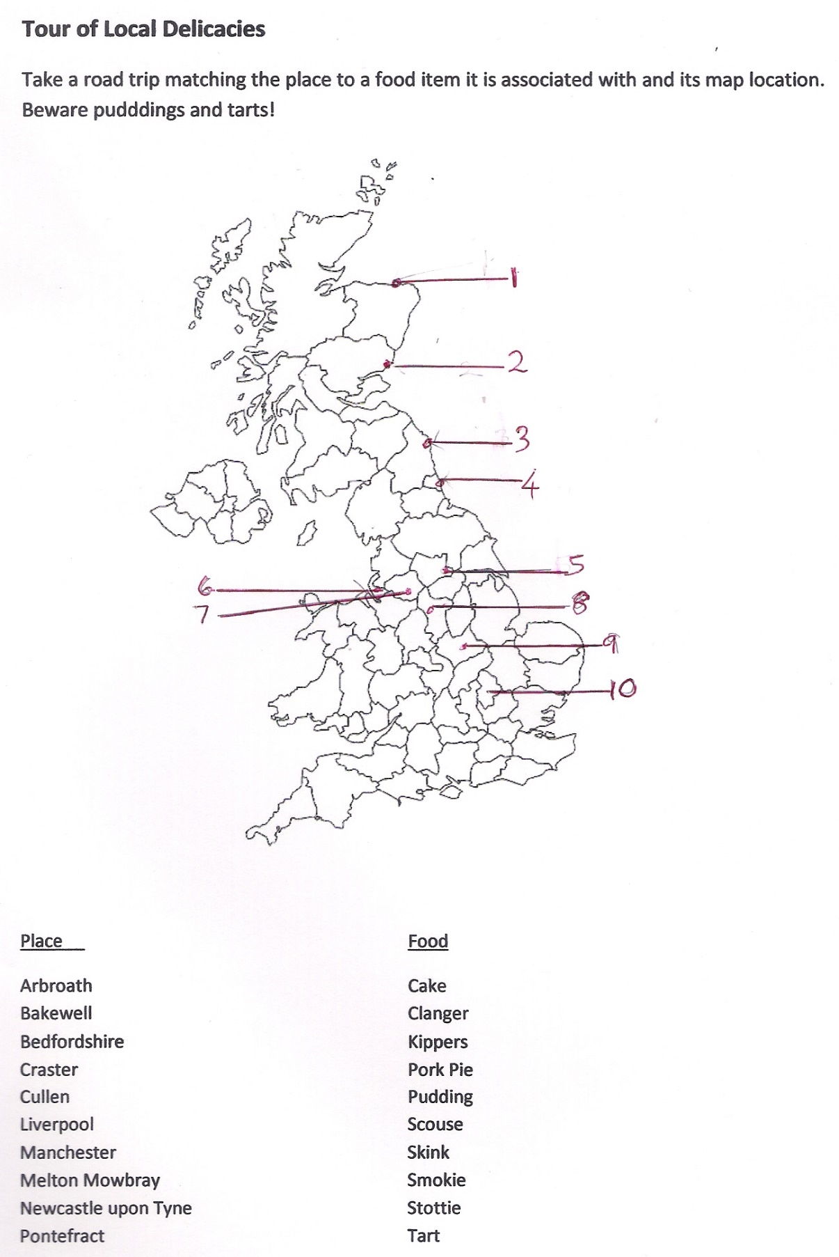

February Quiz answers
Arbroath – map location 2
The Arbroath Smokie is haddock, smoked over hardwood, in around the small fishing town.

Bakewell – map location 8
“The Bakewell Pudding originated back in the 1800s. It was created following a mishap by the cook at a local inn, who misunderstood the recipe for a strawberry tart and ended up topping her creation with a soft set almond custard.” Old Original Bakewell Pudding Shop.

Bedfordshire – map location 10
The Bedfordshire Clanger was originally the food of farm labourers. It is a suet pudding with a meat filling, portable cold or eaten hot on returning home.

Craster – map location 3
Craster Kippers from the Northumberland fishing village of Craster, oak-smoking herring is the traditional way to preserve the fish.

Cullen – map location 1
Cullen Skink is a thick soup made of un-dyed smoked haddock, potatoes and onions. An authentic Cullen skink will use finnan haddie, but it may be prepared with any other undyed smoked haddock. Other variations use milk rather than water, or leeks instead of onions.

Liverpool – map location 6
Scouse is a type of stew, typically made from chunks of meat, usually beef or lamb, potatoes and onion. It is particularly associated with the port of Liverpool, which is why the inhabitants of that city are often referred to as "scousers".

Manchester – map location 7
Manchester Tart was a staple on school dinner menus until the1980s. The original is a variation on a Mrs Beeton recipe. It is custard and fruit tart adorned with toasted coconut.

Melton Mowbray – map location 9
A Melton Mowbray Pork Pie is made with a hand-formed crust. The uncured meat is grey in colour when cooked; the meat is chopped, rather than minced. Created for hunting parties.

Newcastle upon Tyne – map location 4
Stottie (or stotty) cake is a large, round flatbread. It originated just outside of Newcastle. The word "stottie" comes from a local Geordie vernacular meaning "to bounce."

Pontefract – map location 5
Pontefract Cakes are a type of small, roughly circular black sweet measuring approximately 3/4" wide and 1/5" thick, made of liquorice.

